PROJECT DESIGN PHASE
Solution Architecture
Automated Network Request Management in ServiceNow
Date | 14 September 2026
Team ID | —
Project Name | Automated Network Request Management in ServiceNow
Maximum Marks | 4 Marks

Solution Architecture
The architecture bridges the network-request business process and the ServiceNow implementation. The Phase 3 design focuses on the requester-facing Service Portal, Service Catalog configuration, dynamic variables, UI policy behaviour, and request submission experience.
Architecture goals
• Provide a structured entry point for Network Request submission through Service Portal.
• Capture complete requester and service information using catalog variables and variable sets.
• Show or hide fields based on user selections through Catalog UI Policy.
• Maintain a consistent request lifecycle and support status visibility and notifications.
• Provide an architecture that can later connect approval and fulfilment automation.

Figure 1: Architecture and data flow of Automated Network Request Management
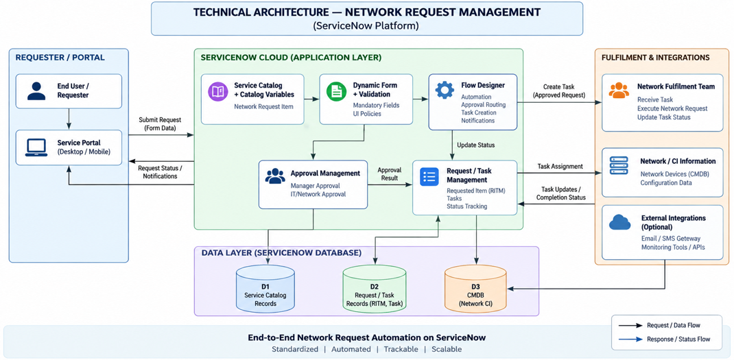

Phase 3 UI/UX Architecture Components
• Service Portal navigation flow for locating and submitting the Network Request catalog item.
• Network Request catalog item with requester information, request variables, and variable set configuration.
• Catalog UI Policy to display the Existing ID field when the connection type is Existing.
• Requester Information variable set with reference and auto-populated email, user name, and phone number fields.
• Request submission and summary experience with request number, status visibility, and notifications.

Phase 3 configuration activities
Activity | ServiceNow configuration | Outcome
1. Service Catalog creation | Create Network Request under Service Catalog and configure category and description. | A reusable Network Request catalog item is available to users.
2. Variables configuration | Configure variable types, order, labels, names, mandatory/read-only behaviour, tooltips, and example text. | The request form captures structured network-request information.
3. Variables creation | Create Requested For, Mobile Number, Type of Connection, Existing ID, Total Amount, Mode of Payment, and Address fields. | The catalog form contains the required request inputs.
4. Variable Set configuration | Create Requester Information variable set with Opened on behalf of, Email ID, User Name, and Phone Number; use reference and auto-population. | Requester information can be captured consistently and populated from the user record.
5. Navigation Flow | Open Service Portal, locate Network Requests, complete the form, and submit. | Users can find and submit the Network Request through the portal.
6. UI Policy | Create a Catalog UI Policy with condition Type of Connection = Existing and make Existing ID visible. | The form dynamically displays the relevant field only when required.

